SQL Assignment
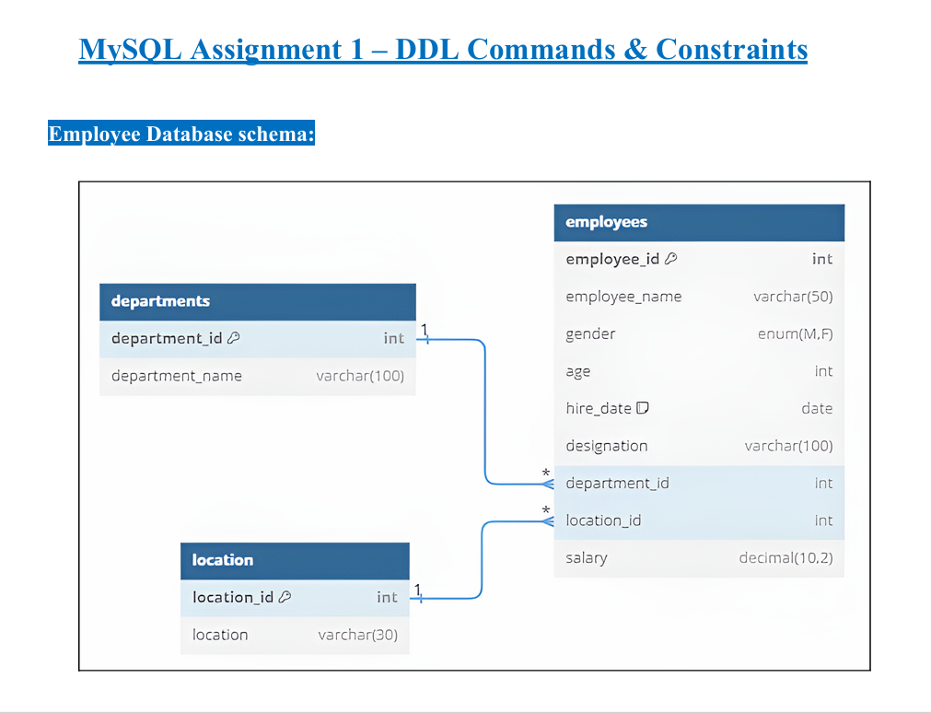

DDL Commands:
Table Creation (CREATE): Write the SQL statements to create a database named “employee” and the following tables based on the provided schema: ⦿ Departments ⦿ Location ⦿Employees

Query
CREATE DATABASE employee;
USE employee;
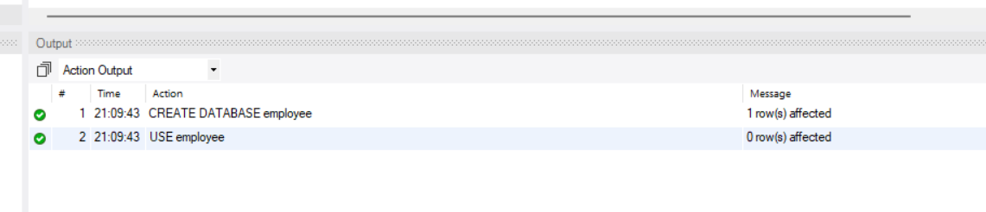

Create the departments table
CREATE TABLE departments (
department_id INT PRIMARY KEY,
department_name VARCHAR(100)
);
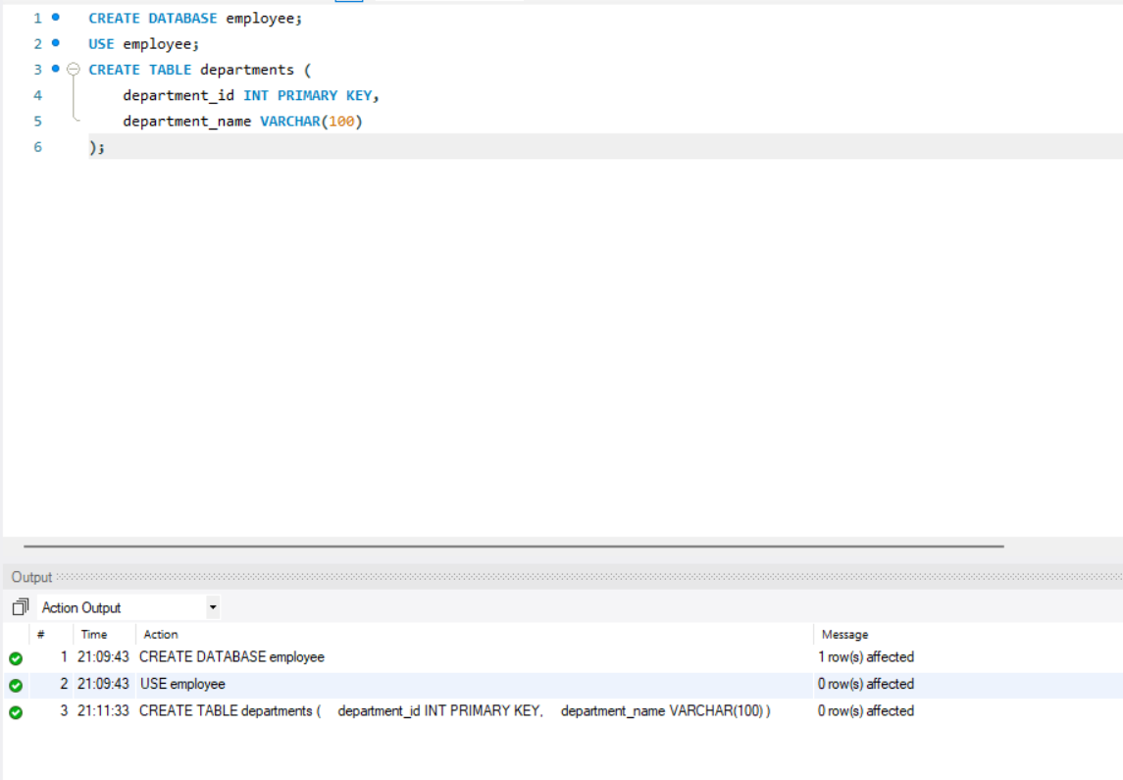

Create the location table
CREATE TABLE location (
location_id INT PRIMARY KEY,
location VARCHAR(30)
);
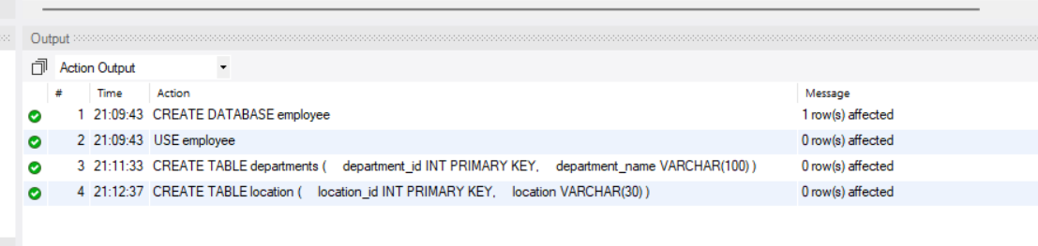

Create the employees table
CREATE TABLE employees (
employee_id INT PRIMARY KEY,
employee_name VARCHAR(50),
gender ENUM('M', 'F'),
age INT,
hire_date DATE,
designation VARCHAR(100),
department_id INT,
location_id INT,
salary DECIMAL(10,2),
FOREIGN KEY (department_id)
REFERENCES departments(department_id),
FOREIGN KEY (location_id)
REFERENCES location(location_id)
);

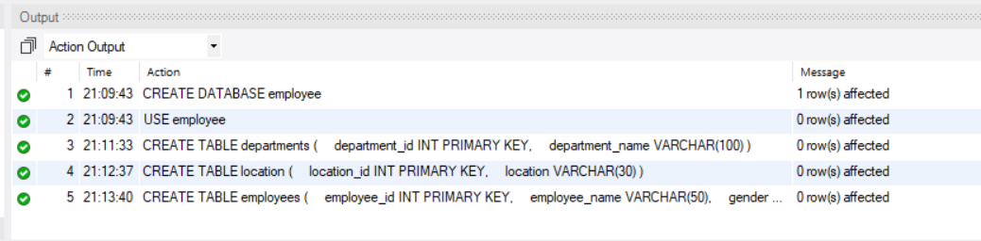

Verify database and tables
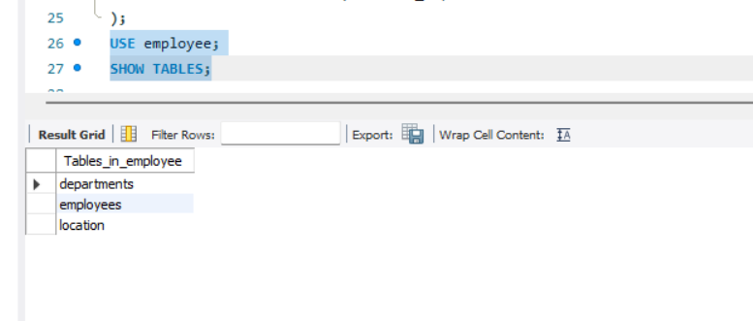
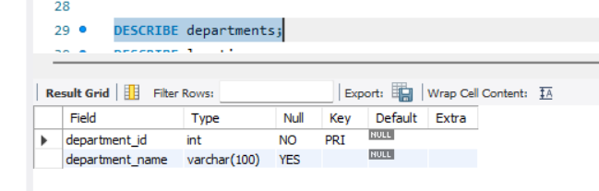
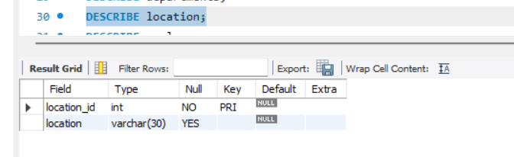
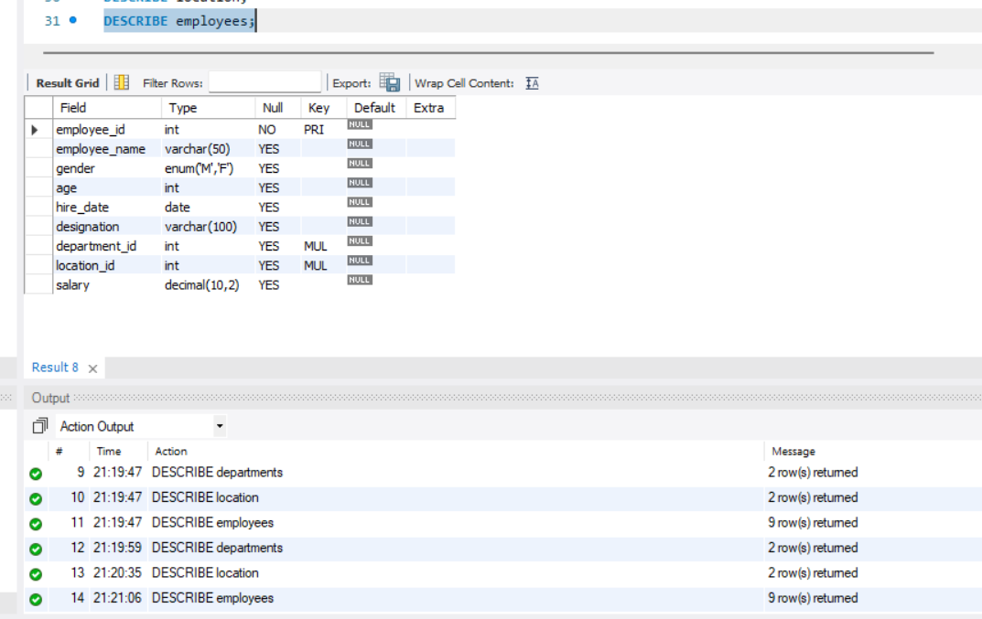

Table Alteration (ALTER):
Consider the following scenarios and write the SQL statements to alter the structure of the tables accordingly: ⦿ Add a new column named "email" to the Employees table to store employee email addresses. ⦿ Modify the data type of the "designation" column in the Employees table to support a wider range of values. ⦿ Drop the “age” column from the Employees table. ⦿ Rename the “hire_date” column to “date_of_joining”.
Add an email column
ALTER TABLE employees
ADD email VARCHAR(100);

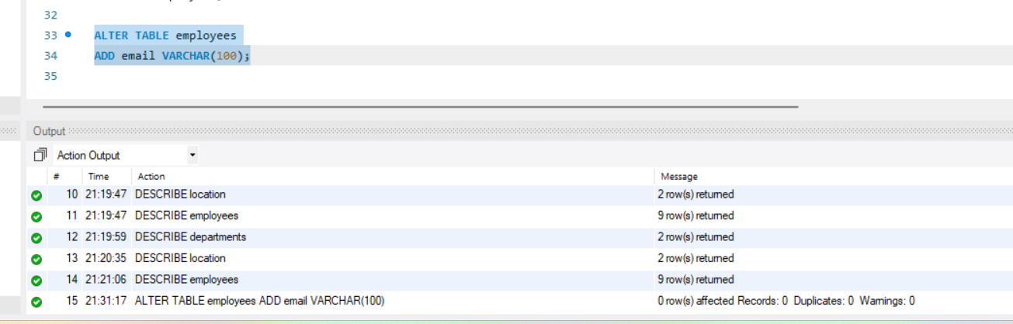

Modify the designation column
ALTER TABLE employees
MODIFY COLUMN designation VARCHAR(200);
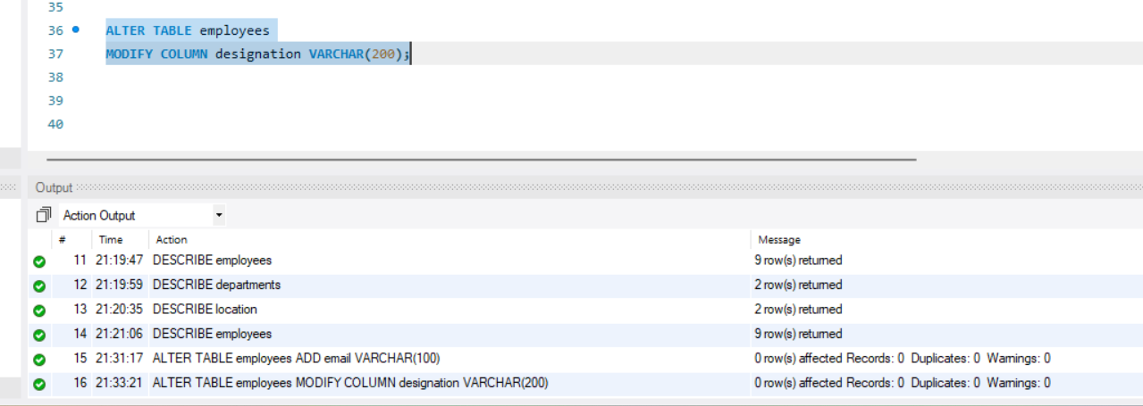

Drop the age column
ALTER TABLE employees
DROP COLUMN age;

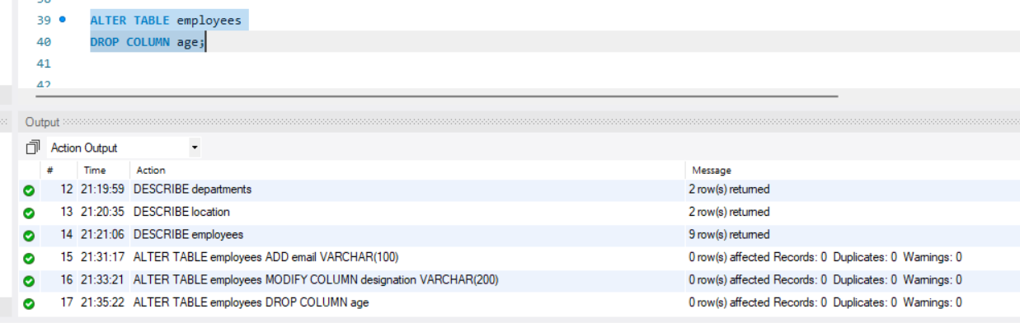

Rename hire_date to date_of_joining
ALTER TABLE employees
RENAME COLUMN hire_date TO date_of_joining;

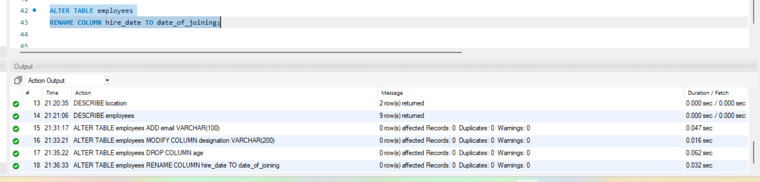

Verification
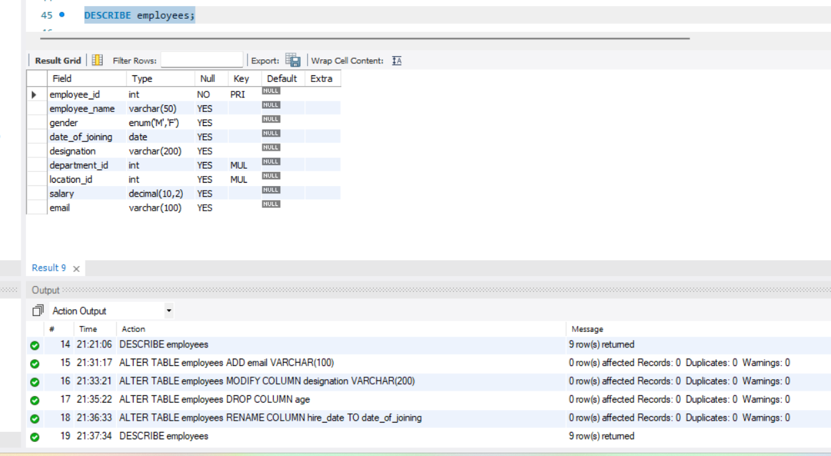

Table Renaming (RENAME):
Rewrite the SQL statements to rename the following tables: ⦿ Rename the "Departments" table to "Departments_Info". ⦿ Rename the "Location" table to "Locations".
Rename departments to Departments_Info
RENAME TABLE departments TO Departments_Info;
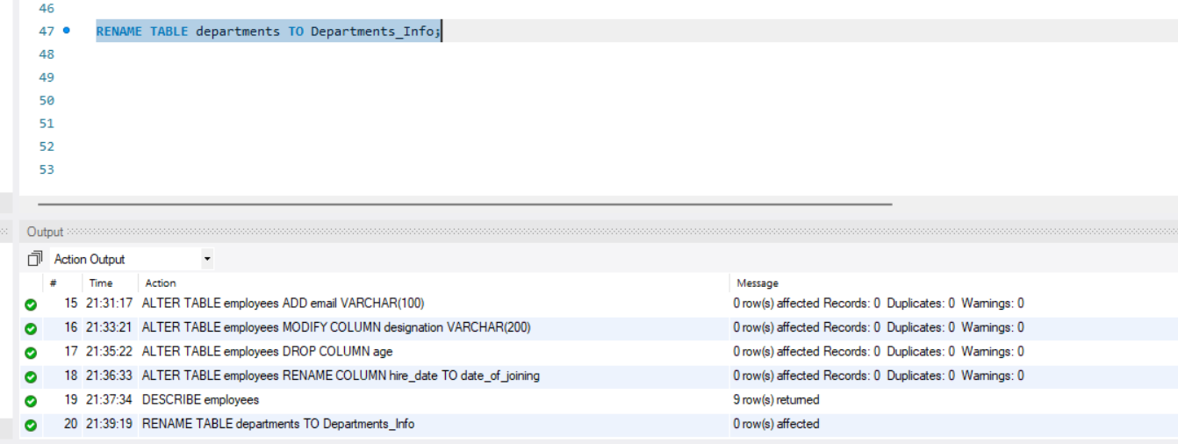

Rename location to Locations
RENAME TABLE location TO Locations;

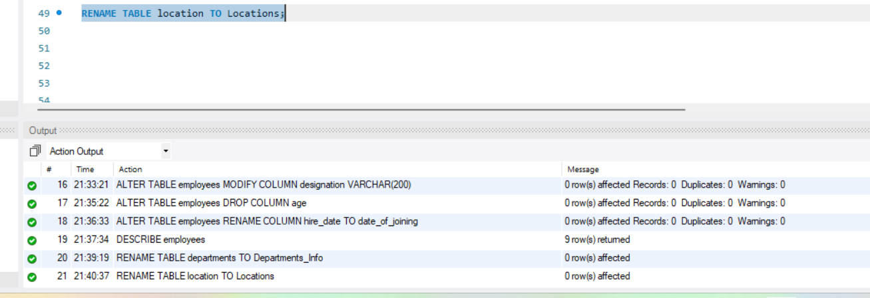

Verification
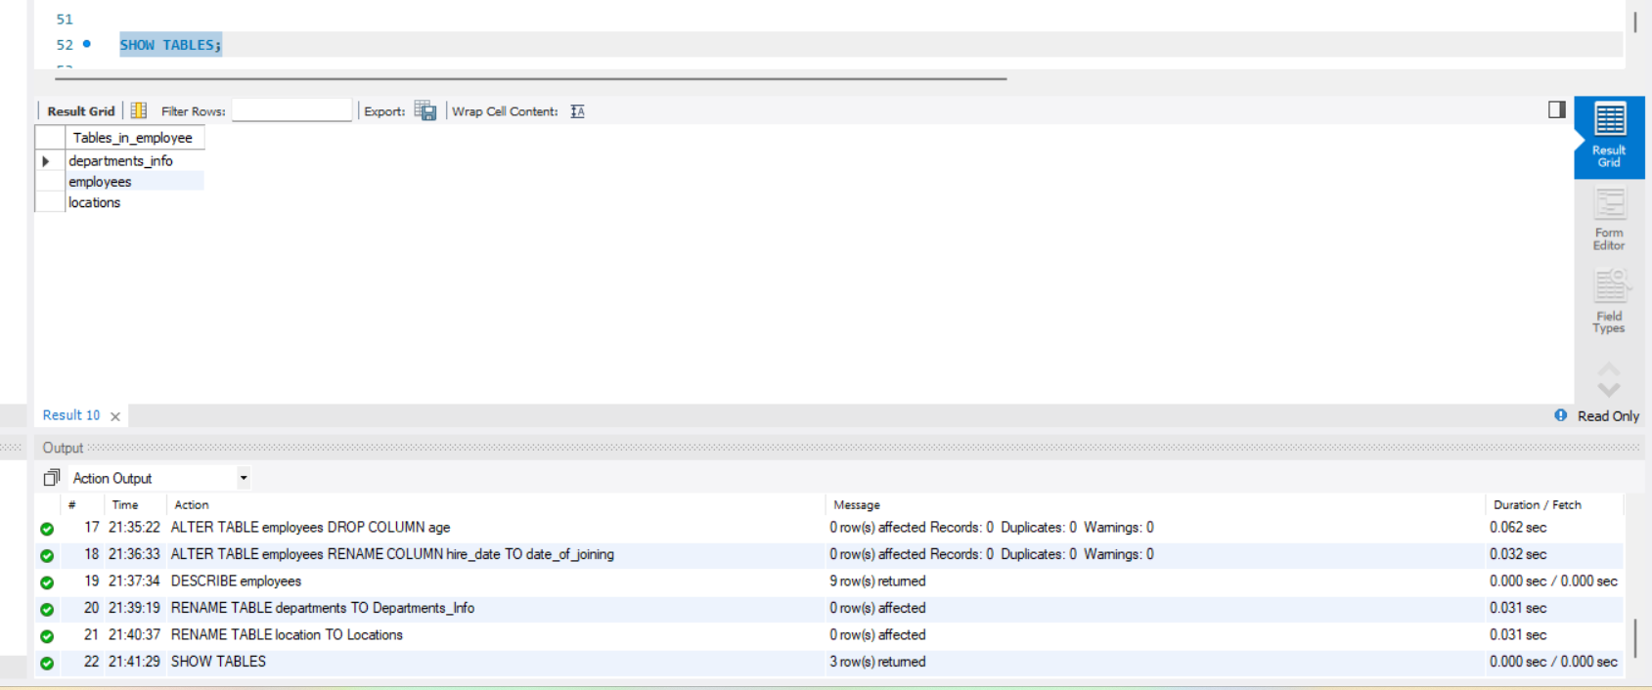

Table Truncation (TRUNCATE):
Write an SQL statement to truncate the Employees table.
Truncate the employees table
TRUNCATE TABLE employees;

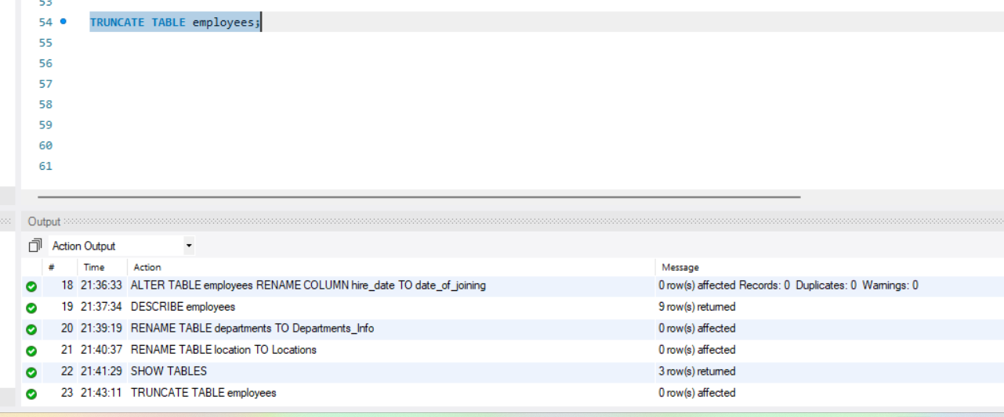

Verification
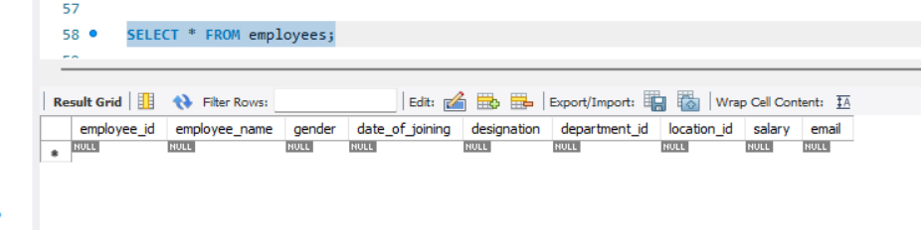

Database & Table Dropping (DROP):
Write the SQL statements to drop the Employees table and then the “employee” database.
Drop the employees table
DROP TABLE employees;
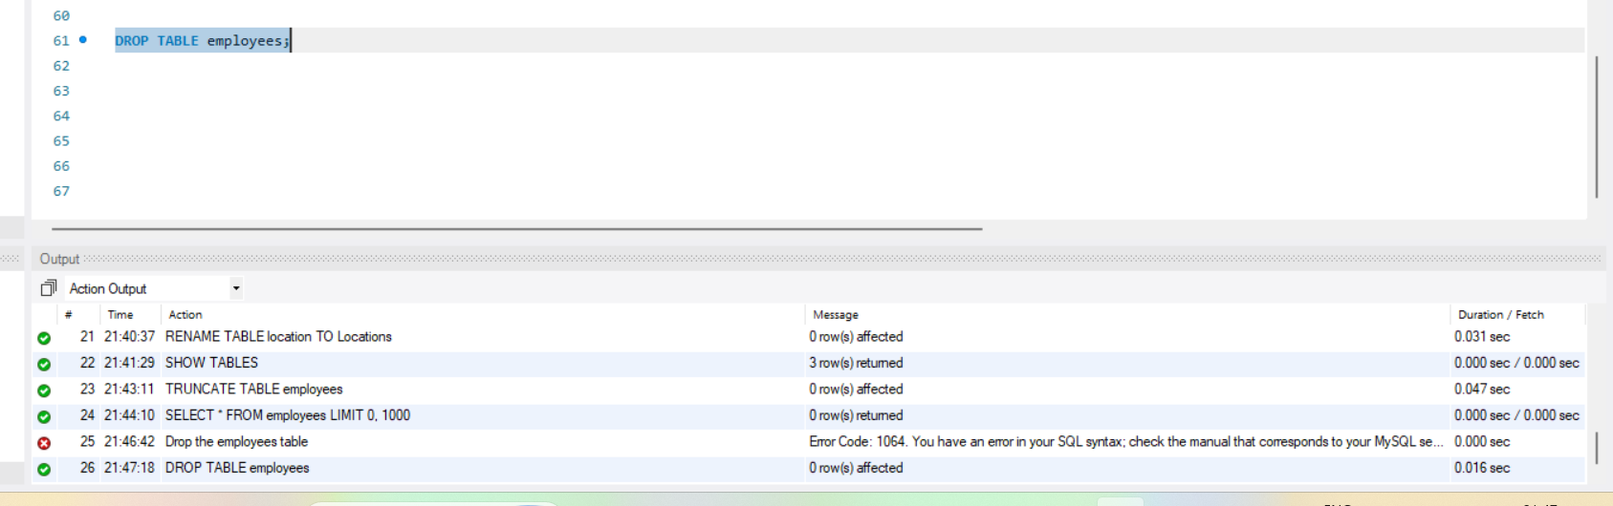

Drop the employee database
DROP DATABASE employee;

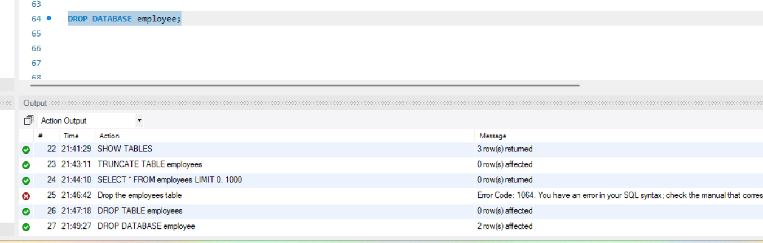

Constraints:
Database Recreation:
Drop the 'employee' database if it exists and recreate it using the provided schema, ensuring that all tables are created with the appropriate constraints as instructed.
Recreate the database
DROP DATABASE IF EXISTS employee;
CREATE DATABASE employee;
USE employee;
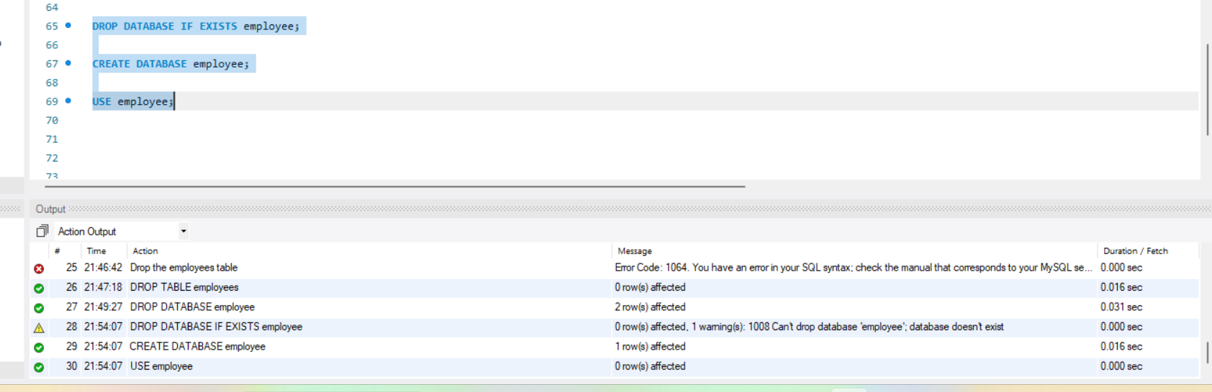
Departments Table:
Ensure that the "department_id" uniquely identifies each department. ⦿ Set up constraints on the "department_name" to avoid duplicate and null entries.
Create the departments table
CREATE TABLE departments (
department_id INT PRIMARY KEY,
department_name VARCHAR(100) NOT NULL UNIQUE
);

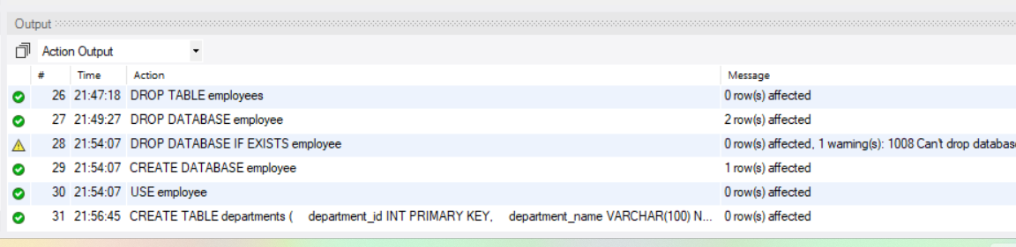

Location Table:
Establish a mechanism to automatically generate unique identifiers for each location, ensuring that they are incremented sequentially. ⦿ Implement constraints to prevent the insertion of null and duplicate locations.
Create the location table
CREATE TABLE location (
location_id INT AUTO_INCREMENT PRIMARY KEY,
location VARCHAR(30) NOT NULL UNIQUE
);
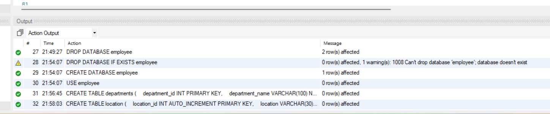

Employees Table:
Guarantee that each employee has a distinct identifier. ⦿ Create a restriction to ensure that the employee's name is always provided. ⦿ Limit the acceptable values for the "gender" field to only 'M' or 'F'. ⦿ Enforce a condition to ensure that the employee's age is 18 or above. ⦿ Automatically assign the current date to the "hire_date" field if not specified. ⦿ Establish links between the "department_id" and "location_id" fields in the "employees" table and their respective tables.
Create the employees table
CREATE TABLE employees (
employee_id INT PRIMARY KEY,
employee_name VARCHAR(50) NOT NULL,
gender ENUM('M', 'F'),
age INT,
hire_date DATE DEFAULT (CURRENT_DATE),
designation VARCHAR(100),
department_id INT,
location_id INT,
salary DECIMAL(10,2),
CONSTRAINT chk_employee_age
CHECK (age >= 18),
CONSTRAINT fk_employee_department
FOREIGN KEY (department_id)
REFERENCES departments(department_id),
CONSTRAINT fk_employee_location
FOREIGN KEY (location_id)
REFERENCES location(location_id)
);
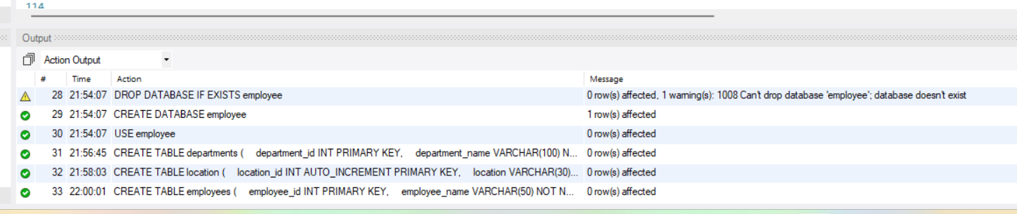

Verify the tables and constraints
SHOW TABLES;

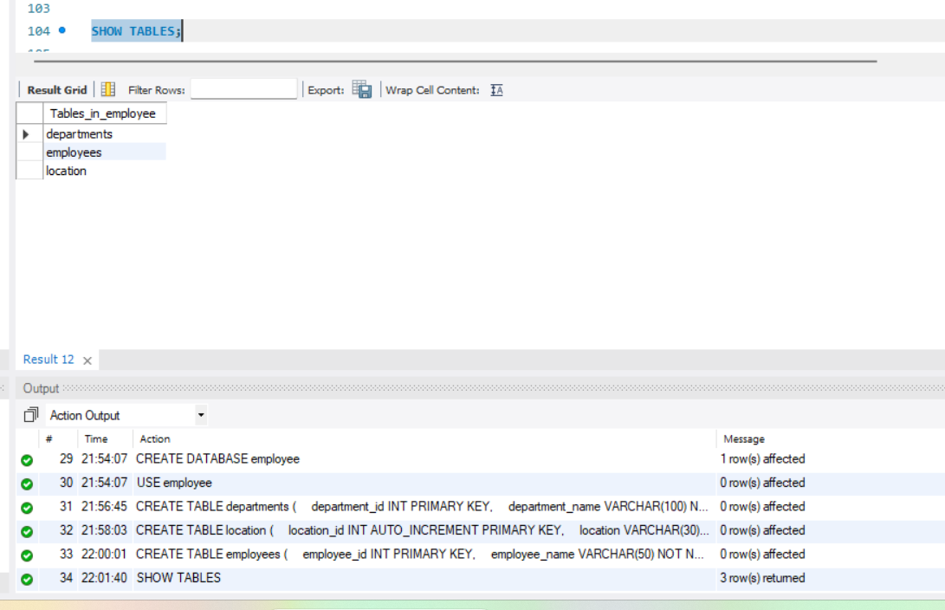

DESCRIBE departments;
DESCRIBE location;
DESCRIBE employees;
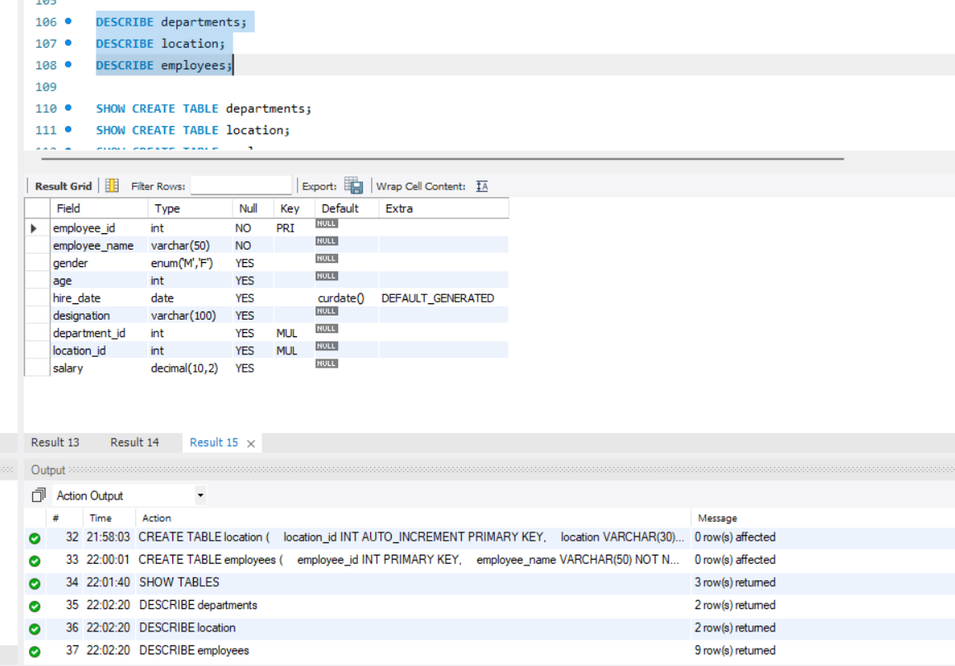

SHOW CREATE TABLE departments;

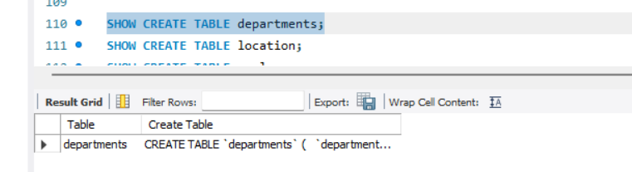
SHOW CREATE TABLE location;

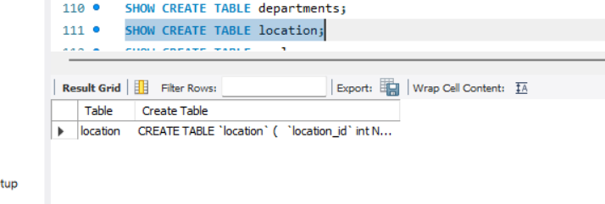
SHOW CREATE TABLE employees;
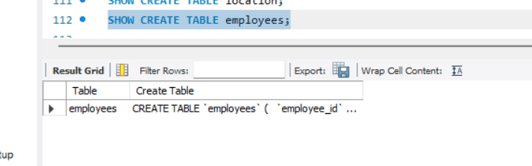

Test the constraints
INSERT INTO departments
VALUES (1, 'IT');
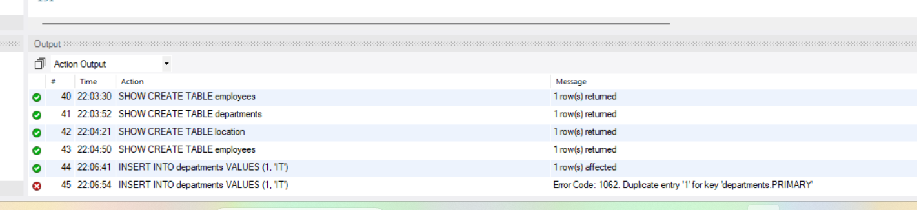

INSERT INTO location (location)
VALUES ('Nellore');
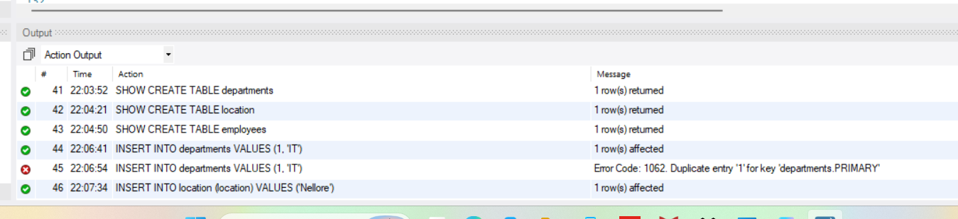

INSERT INTO employees (
employee_id,
employee_name,
gender,
age,
designation,
department_id,
location_id,
salary
)
VALUES (
101,
'Ravi',
'M',
25,
'Data Analyst',
1,
1,
35000.00
);

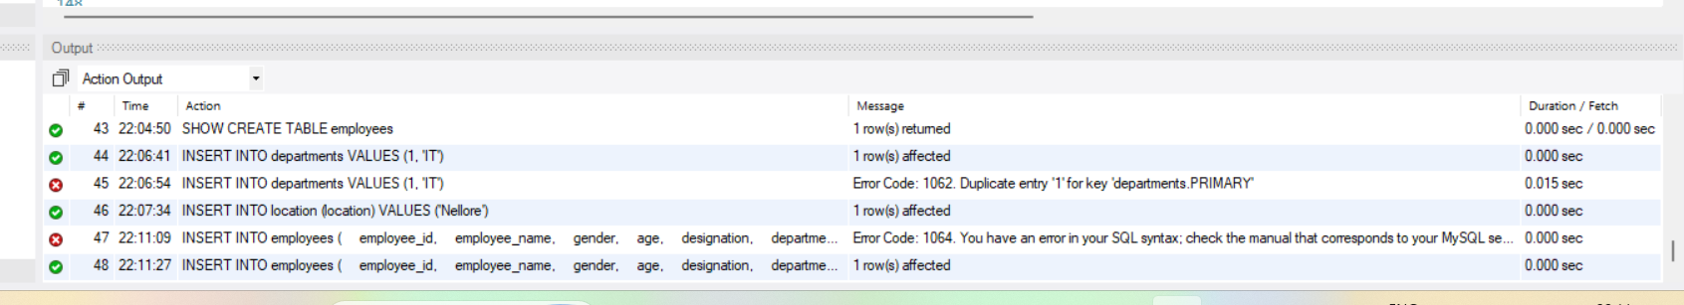

Verification
SELECT * FROM employees;


